1. 将实验三的三题进行改写，在Servlet控制器中获取信息，验证后根据具体情况跳转到对应页面，成功请求转发到成功页面，否则重定向跳转到失败页面（可将动态验证码添加在页面上）

* 登录页面，提交用户名、密码及身份

改写一：支持中文，确保两种表单提交方式（get、post）都支持中文，另外对程序的空对象情况进行处理。

改写二：比如登录页面除了之前的用户名、密码另外再加上所在专业（计算机、软件工程及网络工程，单选框或下拉列表框皆可），登录成功后根据身份进行跳转，进入对应的页面，页面需显示****专业学号姓名。登录失败转向失败页面，并进行报错！

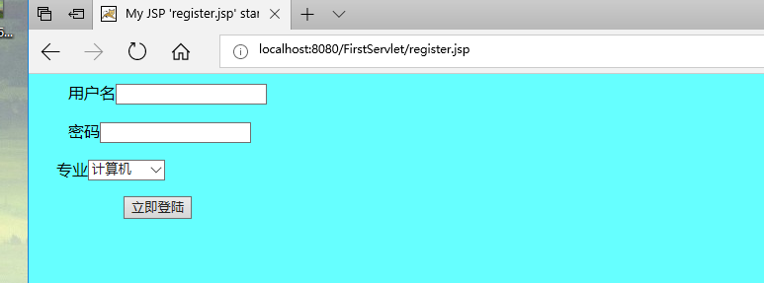

<%@ page language=*"java"* import=*"java.util.*"* pageEncoding=*"utf-8"*%>

<%

String path = request.getContextPath();

String basePath = request.getScheme()+"://"+request.getServerName()+":"+request.getServerPort()+path+"/";

%>

<!DOCTYPE HTML PUBLIC "-//W3C//DTD HTML 4.01 Transitional//EN">

<html>

<head>

<base href=*"*<%=basePath%>*"*>

<title>My JSP 'register.jsp' starting page</title>

<meta http-equiv=*"pragma"* content=*"no-cache"*>

<meta http-equiv=*"cache-control"* content=*"no-cache"*>

<meta http-equiv=*"expires"* content=*"0"*>

<meta http-equiv=*"keywords"* content=*"keyword1,keyword2,keyword3"*>

<meta http-equiv=*"description"* content=*"This is my page"*>

<!--

<link rel="stylesheet" type="text/css" href="styles.css">

-->

</head>

<body bgcolor=*"#66FFFF"*>

<form action=*"success.jsp"* method=*"post"*>

<p><label >&nbsp;&nbsp;&nbsp;&nbsp;&nbsp;&nbsp;&nbsp;&nbsp;用户名</label><input name=*"name"* type=*"text"* /></p>

<p><label>&nbsp;&nbsp;&nbsp;&nbsp;&nbsp;&nbsp;&nbsp;&nbsp;密码</label><input name=*"password"* type=*"text"* /></p>

<p><label>&nbsp;&nbsp;&nbsp;&nbsp;&nbsp;专业</label><select name=*"place"*></p>

<option value=*"place1"*>计算机</option>

<option value=*"place2"*>软件工程</option>

<option value=*"place2"*>网络工程</option>

<option value=*"place2"*>信息管理</option></select>

<p>&nbsp;&nbsp;&nbsp;&nbsp;&nbsp; &nbsp;&nbsp;&nbsp;&nbsp;&nbsp;&nbsp;&nbsp;&nbsp;&nbsp;&nbsp;&nbsp;&nbsp;&nbsp; &nbsp;&nbsp;<input name=*"register"* type=*"submit"* value=*"立即登陆"* /></p>

<p>&nbsp;&nbsp;&nbsp;&nbsp;&nbsp;&nbsp;

</label> </p>

<p></p>

<p></p>

<p></p>

<p></p>

</form>

</body>

</html>

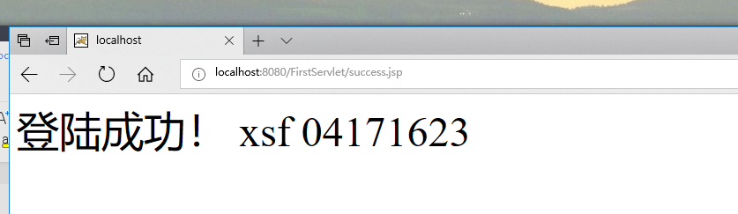

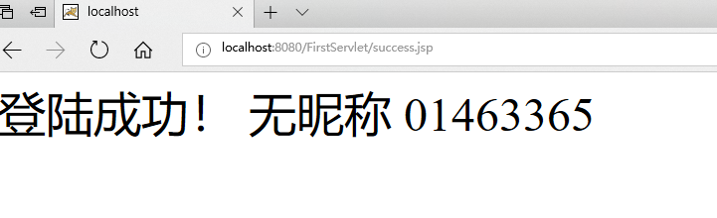

<%@ page contentType=*"text/html;charset=utf-8"* %>

<%response.setCharacterEncoding("utf-8");

response.setHeader("iso-8859-1","utf-8");

request.setCharacterEncoding("utf-8");

String name = request.getParameter("name");

String psd = request.getParameter("password");

**if**(name.equals("")||psd.equals("")){

response.setHeader("Refresh","1;url=fail.jsp");

**return**;

}

**else**{

String acc=request.getParameter("account");

String yourName=request.getParameter("name");

out.println("<HTML><BODY><Font size=8><P>登陆成功！");

out.println(name);

out.println(psd);

//out.println(acc);

out.println("</P><BR></BR></FONT></BODY></HTML>");

}

%>

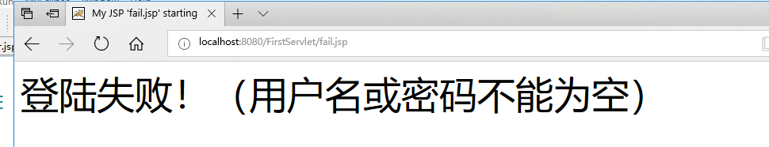

<%@ page language=*"java"* import=*"java.util.*"* pageEncoding=*"utf-8"*%>

<%

String path = request.getContextPath();

String basePath = request.getScheme()+"://"+request.getServerName()+":"+request.getServerPort()+path+"/";

%>

<!DOCTYPE HTML PUBLIC "-//W3C//DTD HTML 4.01 Transitional//EN">

<html>

<head>

<base href=*"*<%=basePath%>*"*>

<title>My JSP 'fail.jsp' starting page</title>

<meta http-equiv=*"pragma"* content=*"no-cache"*>

<meta http-equiv=*"cache-control"* content=*"no-cache"*>

<meta http-equiv=*"expires"* content=*"0"*>

<meta http-equiv=*"keywords"* content=*"keyword1,keyword2,keyword3"*>

<meta http-equiv=*"description"* content=*"This is my page"*>

<!--

<link rel="stylesheet" type="text/css" href="styles.css">

-->

</head>

<body>

<Font size=*8*><P>登陆失败！（用户名或密码不能为空）</P>

<BR></BR></FONT></BODY></HTML><br>

</body>

</html>